**Project Report Template**

**AN OVERVIEW OF EV CHARGING INFRASTRUCTURE**

1. **Introduction**
   1. Overview

Electric Vehicles (EV) can be charged in a variety of ways, depending on location and requirement. Accordingly, charging infrastructure for EVs is of different types and designed for different applications. Specifications and standards for EV chargers, also known as electric vehicle supply equipment (EVSE), vary from one country to another, based on available EV models in the market and the characteristics of the electricity grid. This chapter explains the technical concepts of electric vehicle charging infrastructure and highlights the need for a contextual approach to local planning and implementation of EV charging network.

* 1. Purpose

Electric vehicles use electricity to charge their batteries instead of using fossil fuels like petrol or diesel. Electric vehicles are more efficient, and that combined with electricity cost means that charging an electric vehicle is cheaper than filling petrol or diesel for you travel requirements.

1. **Problem definition & design thinking**
   1. Empathy map



2.2 Ideation & brainstorming Map





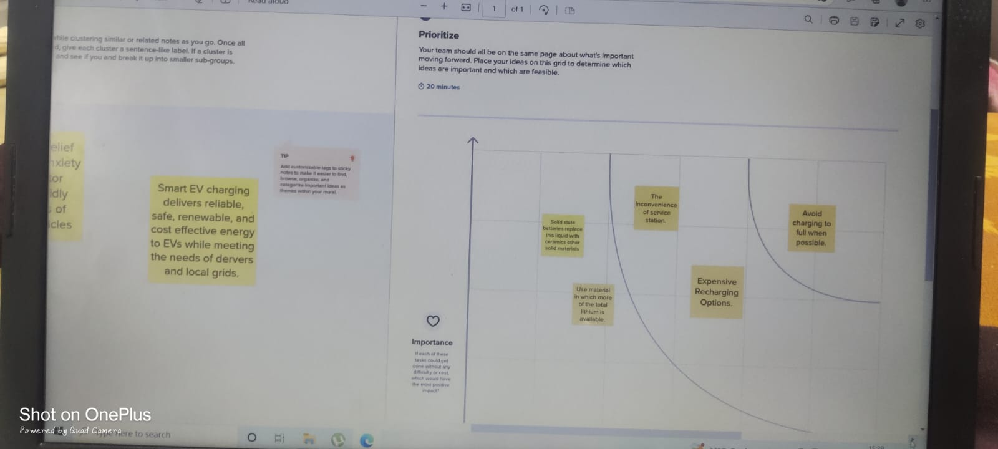

**3. Result**























**4.Advantages & Disadvantages**

ADVANTAGES OF ELECTRIC VEHICLE

* **Environment-friendly –** Electric vehicles do not use fuels for combustion and hence there is no emission or exhaust of gases. Vehicles using fossil fuels are large contributors to harmful gas buildup in the environment so the use of an electric car can help contribute to a cleaner atmosphere.
* **Renewable energy source –** Electric vehicles run on electricity that is renewable whereas conventional cars work on the burning of fossil fuels that exhaust the fossil-fuel reserves on earth.
* **Cost-effective –** Electricity vehicles have fewer moving parts so wear and tear is less as compared to conventional auto parts. Repair work is also simple and less expensive compared to combustion engines.
* **Less noise and smoother motion -** Electric vehicles give a much smoother driving experience. The absence of rapidly moving parts makes them much ignore with low sound generation.
* **Government support –** Governments in various countries have offered tax credits as an incentive to encourage people to use electric vehicles as a go-green initiative.

DISADVANTAGES OF ELECTRIC VEHICLE

* **High initial cost -** Electric vehicles very ignores, and many consumers consider them not as affordable as conventional vehicles.
* **Charging station limitations –** People who need to drive long distances are worried about getting suitable charging statins midway which are not available everywhere.
* **Recharging takes time –** Unlike conventional cars that require a few minutes for refilling fuel, recharging of the electric vehicle takes much more time which is generally a few hours.
* **Limited choices –** Presently there aren’t too many electric models of cars available to choose from when it comes to the looks, designs, or customized versions.
* **Less driving range -** The driving range of the electric vehicles is found to be less as compared to conventional vehicles. Electric vehicles can be suitable for day-to-day but can be problematic for a long-distance journey.

**5. Applications**

ELECTRIC VEHICLE APPLICATIONS

EPC manufactures several on-board battery chargers for electric vehicles. Most of our EV chargers are available with a standard J1772 vehicle connector, which allows for charging at all public Level 1 & 2 charging stations.

For your fast charging needs, we also offer level 3 charging inlets on several of our on board chargers. Both CGADeMO and SAE J1772 combo inlets are available.

**6. Conclusion**

The progress that the electric vehicle industry has seen in recent years is not only extremely welcomed, but highly necessary considering the increasing global greenhouse gas levels. As demonstrated within the economic, social, and environmental analysis sections of this webpage, the benefits of electric vehicles far surpass the costs. The biggest obstacle to the widespread adoption of electric-powered transportation is cost related, as gasoline and the vehicles that run on it are readily available, convenient, and less costly. As is demonstrated in out timeline, we hope that over the course of the next decade technological advancements and policy changes will help ease the transition from traditional fuel-powered vehicles. Additionally, the realization and success of this industry relies heavily on the global population, and it is our hope that through mass marketing and environmental education programs people will feel incentivized and empowered to drive an electric-powered vehicle. Each person can make a difference so go electric and help make a difference!

**7. The Future Scope of Electric vehicles**

* Electric vehicles (EV) are the future not only of transport but of our planet. Can electric vehicles ever face a more serious form of gridlock, however? These vehicles are plugged into a charging station at a low voltage. There are no emissions released from these vehicles.
* The future potential of electric vehicles is enormous. The obvious starting point for these vehicles is the charging station. This is, however, only the first step in a potential journey which will see charge Banks and other industrial areas as well as homes and cities. The future scope of electric vehicles is therefore massive.
* The technology for electric vehicles has been around since the 70’s in labs such as NASA. The present-day technology will no doubt be far more advanced in a few years' time. Some believe that we will soon see electric vehicles that can power themselves by harvesting energy from their environment. Such vehicles will require very little maintenance and can even run off alternative energy sources such as wind.
* One problem faced by electric vehicles is that they do not fit into many parking spaces. As advances are made in technology, this problem will seem to be lessened with time. Other obstacles are also that electric vehicles use electricity which results in a pollution issue. There are solutions though, for both these issues. The charging stations for electric vehicles offer a way in which pollution can be reduced and also help to create jobs in regions where employment is little.
* The future scope of electric vehicles is therefore enormous. We have The future scope of electric vehicles is therefore enormous. We have already seen that technology for these vehicles is here and becoming far more advanced. We now know that such vehicles can provide us with great flexibility, and we will soon see that potential.
* It will also be interesting to see the impact of regulations which will come into force from the EU and US. These regulations are set to reduce petrol engine vehicles use. As electric vehicles grow in popularity, so will the need to reduce their use. It is clear that there will be a need to develop new zero emission technologies.
* This study provides detailed information on the future scope and the historical data analysis. It concludes by looking at the present prospects and gives a good guide as to how far technology has come. Future scope is estimated to continue growing rapidly as electric vehicles become more popular. More detailed information can be found in the full report which is available to download from the website. This full report which is available to download from the website. This provides an outline of the main points covered in the report.
* The market research report provides a comprehensive overview of the current trends in the global market. It discusses the present-day technology, the outlook for the future and the position of electric vehicles in this market segmentation. The analysis looked at four key areas. These are power source, battery technology, charging systems and regional analysis.
* Power source is one of the most important aspects and the global market segmentation is analyzed with detailed information. Present-day electric vehicles use different sources such as wind power, solar power and hydroelectric power. Most of these technologies have evolved in Africa. Some of the countries which have developed these technologies are Morocco, South Africa, Tanzania, Namibia, Zimbabwe and Brazil. It should be noted that these nations all have very low fuel costs, and this means that it is very affordable to install a charging system on the cars.
* Batteries have been the primary concern all over the world. With the development in technology, lithium-ion batteries are replacing ordinary alkaline batteries. This has posed a serious challenge to the manufacturers. The market research report offers details of the major key players of this industry and the various plans that are taken by them to overcome the challenges.

**8. Appendix**

SOURCE CODE

Dashboard public link

<https://public.tableau.com/views/Book1graph2/Dashboard1?:language=en-US&publish=yes&:display_count=n&:origin=viz_share_link>

Story public link

<https://public.tableau.com/views/Book1graph2/Story1?:language=en-US&publish=yes&:display_count=n&:origin=viz_share_link>

Video link

<https://www.mediafire.com/file/rxuwkggpfwund5b/sbs+project+video.mp4/file>